SUBJECT NAME AND CODE: WEB DEVELOPMENT
WEBE5020
FULL NAME: SAAHEERAH MAJIET
STUDENT NUMBER: ST10516777
GROUP: 1

TABLE OF CONTENTS:
Contents
BUSINESS PROPOSAL 2 3
1. Organisation Overview 3
Mission and Vision Statement: 3
Target Audience: 3
2. Website Goals and Objectives: 3
The website's goals are to encourage understanding, increase donations, and provide information on ongoing international programs. 3
Goals: 3
• Spread public awareness of charitable organisations 3
• Encourage online sponsorships and donations 3
• Offering updates on relief operations after natural disasters. 3
• Be truthful and open about how donations are used for operations. 3
KPIs: 3
3. Current Website Analysis: 3
The current Gift of the Givers website offers helpful details on donation options and programs. However, there is opportunity for improvement to strengthen accessibility and engagement. 3
Strengths : 3
Weaknesses: 3
Improvements: 4
4. Proposed Website Features and Functionality 4
Website Features 4
Homepage: Shows the most recent disasters, emergencies, and methods that users can donate to or support. 4
• About Page: Provides information on goals, history, mission, and the importance of the organization. 4
• Projects Page: Shows the organization's completed and ongoing relief operations. 4
• Donation Page: Enables users to make safe online contributions using a variety of safe payment options. 4
• Volunteer Page: This section of the website allows people to register and volunteer for humanitarian projects. 4
• Contact Page: Offers an inquiry form and all the contact information needed to get in touch with the organization. 4
Website Functionality 4
5. Design and User Experience: 5
Colour Scheme: 5
We'll use green, white, and blue. Green represents hope and emergency assistance, white for peace and transparency, and blue for trust and dependability. 5
Typography: 5
6. Technical Requirements 6
Hosting and Domain requirements: 6
7. Timeline and Milestones 7
8. Budget 7
9. References 8

BUSINESS PROPOSAL 2

1. Organisation Overview
NAME: Gift of the Givers Foundation
The largest humanitarian aid, relief, and emergency response organisation in Africa is is called Gift of the Givers. It was set up in South Africa and provides emergency aid both locally and internationally, providing food packages, medical care, water supplies, and emergency relief. The organisation is known for its rapid response to community emergencies, earthquakes, droughts, and floods.

Mission and Vision Statement:
Gift of the Givers' aim is to help individuals in need urgently, effectively, and with kindness, regardless of their nationality, colour, or religion. The goal is to create a future where basic human needs are always met, and communities get help during emergencies.

Target Audience:
- Communities affected by natural disasters (droughts, fires, floods)
- Vulnerable and families with low incomes
- Medical supplies required for hospitals and healthcare facilities
- International emergency areas in need of emergency assistance.

2. Website Goals and Objectives:

The website's goals are to encourage understanding, increase donations, and provide information on ongoing international programs.

Goals:

Spread public awareness of charitable organisations

Encourage online sponsorships and donations

Offering updates on relief operations after natural disasters.

Be truthful and open about how donations are used for operations.

KPIs:
- The annual number of visits to websites
- The transformation rate of contributions
- Involvement in project updates and news
- The number of volunteers that signed up through the online platform

3. Current Website Analysis:

The current Gift of the Givers website offers helpful details on donation options and programs. However, there is opportunity for improvement to strengthen accessibility and engagement.

Strengths :
* Properly established program and emergency operation information
* There are ways to donate.
* Regular updates on responses to the disasters

Weaknesses:
- More digital components
- ﻿﻿On mobile devices, the layout seems outdated.
- ﻿﻿For simple access, navigation could be made better.

Improvements:
- Implement an ongoing donation tracker* Improve performance on mobile devices
- ﻿﻿Includes a live map of current relief zones for disasters.

4. Proposed Website Features and Functionality

Website Features

Homepage: Shows the most recent disasters, emergencies, and methods that users can donate to or support.

About Page: Provides information on goals, history, mission, and the importance of the organization.

Projects Page: Shows the organization's completed and ongoing relief operations.

Donation Page: Enables users to make safe online contributions using a variety of safe payment options.

Volunteer Page: This section of the website allows people to register and volunteer for humanitarian projects.

Contact Page: Offers an inquiry form and all the contact information needed to get in touch with the organization.

Website Functionality
- Completely hidden, trustworthy online donating method
- Mobile, tablet, and desktop responsive layouts
- A project and news search function
- An online map for emergency response
- Pages that load rapidly to enhance user experience

5. Design and User Experience:
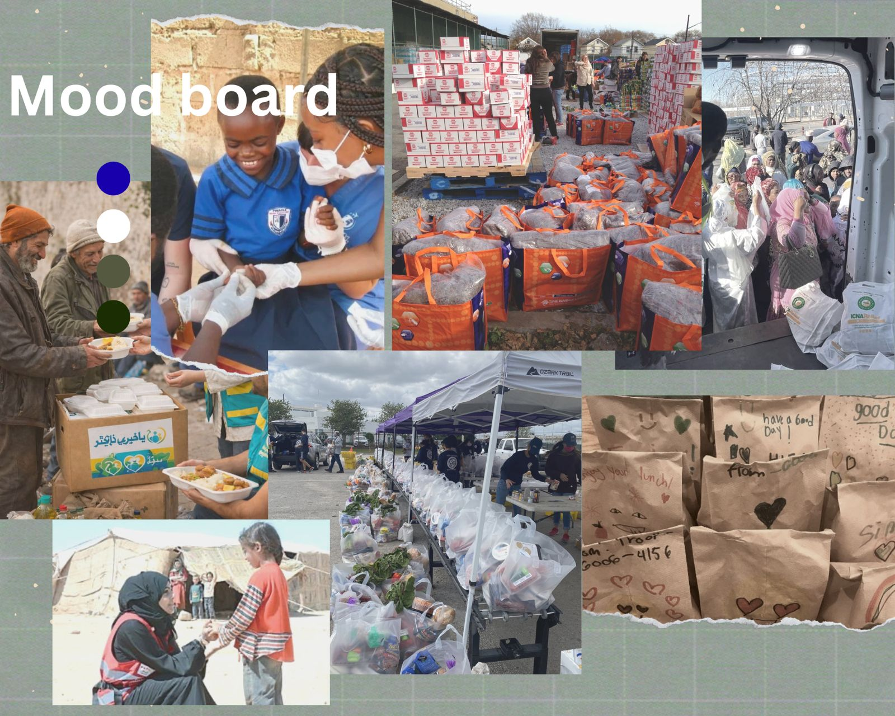

Colour Scheme:

We'll use green, white, and blue. Green represents hope and emergency assistance, white for peace and transparency, and blue for trust and dependability.

Typography:

Regarding accessibility, basic sans serif fonts like Arial will be used. The body text will be simple and straightforward, but headings will be bolded to draw attention to important details.

Layout and Design:
To ensure simple navigation, an organised and structured layout will be used. Important details will be emphasised, include contributions connections and serious appeals. To encourage awareness and emotional connection, images from genuine assistance efforts will be used.

User Experience Considerations:
The website will be made with ease of use, speed, and accessibility in thoughts With just a few clicks, users will be able to locate information or make contributions. Additionally, the design will be flexible for users using smartphones to view the website.

Low-Fidelity Wireframes:

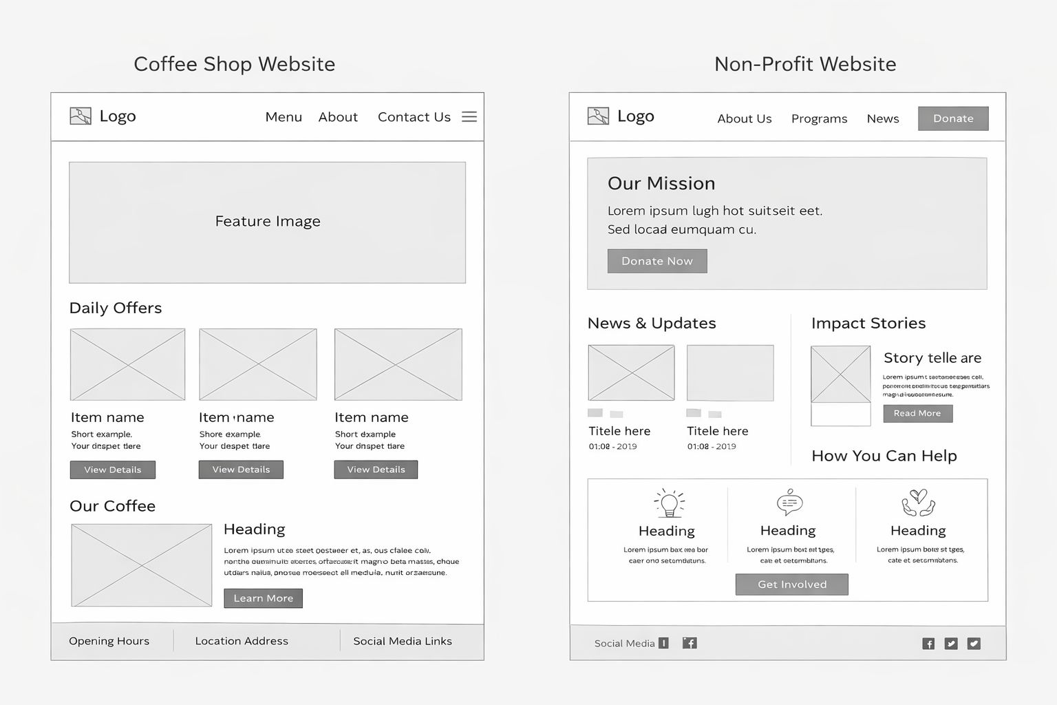

6. Technical Requirements

Hosting and Domain requirements:
- Domain: giftofthegivers.org (official organisation domain)
- Hosting: Cloud-based hosting for reliability and scalability
- Security: SSL/TLS encryption to protect donation transactions and personal data
- Availability: 99.9% uptime to ensure the site is always accessible during emergencies

7. Timeline and Milestones
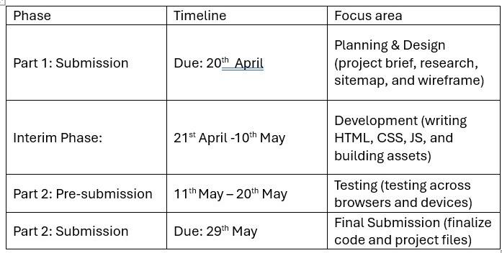

8. Budget
- Domain: R100 – R300 per year
- Hosting: R500 – R1,200 per year
- Security (SSL): Free – R500 per year
- Development tools: Free (VS Code, GitHub)
- Images and media: Free (royalty-free sources)

9. References
ChatGPT, 2026. ChatGPT (April version). Available at: https://chat.openai.com (Accessed: 20 April 2026).
QuillBot, 2026. QuillBot Paraphrasing Tool. Available at: https://quillbot.com (Accessed: 20 April 2026).
Google, 2026. Google Search Engine. Available at: https://www.google.com (Accessed: 20 April 2026).
Gift of the Givers, 2026. Official Website. Available at: https://giftofthegivers.org (Accessed: 20 April 2026).
Duckett, J., 2011. HTML and CSS: Design and Build Websites. Indianapolis: Wiley.
Mozilla Developer Network, 2025. HTML, CSS and JavaScript Guide. Available at: https://developer.mozilla.org (Accessed: 20 April 2026).
W3Schools, 2025. Web Development Tutorials. Available at: https://www.w3schools.com (Accessed: 20 April 2026).
Unsplash, 2025. Free stock images. Available at: https://unsplash.com (Accessed: 20 April 2026).
Pexels, 2025. Free stock photos. Available at: https://www.pexels.com (Accessed: 20 April 2026).
Pixabay, 2025. Free images and royalty-free stock. Available at: https://pixabay.com (Accessed: 20 April 2026).

